Online eAgriculture with bidding system

ABSTRACT:

The agricultural information system provides is users to get online information about, fruits, vegetables statistical details and new tendencies.

The main features of the information system includes information retrieval facilities for Farmers are Import product for Bidding from anywhere in the form of obtaining statistical information about fruits, vegetables, statistical information about exports etc. Customer can buy Crops with bidding.

INTRODUCTION:

Bangladesh is an agriculture dependent country. Agriculture is the largest employment in Bangladesh.

Online agriculture is becoming a suitable way to make all your purchases crops, whether you’re at home or anywhere.

Taking to online agriculture to search Crops or service, compare prices & to shop by bidding.

PROBLEM STATEMENT:

In Bangladesh, the agricultural sector is one of the main contributors to the national GDP.

An amount of 15.95 %(including fisheries) of the total GDP in the fiscal year 2014-2015 of our country has come from the agricultural sector (BER, 2015).

But, most of the farmers of Bangladesh are still in lack of modern agricultural knowledge and information. People having internet facilities have better access to information, which help them to acquire better position in economic activities.

PROJECT OBJECTIVES:

The following objectives are needed as a guide to achieve the goal of our project. They are

* To design a website that have admin, farmer & customer interface using Laravel framework.
* Farmer can import her crops for selling and customer can buying crops with bidding.
* Sustain the economic viability of farms operations.
* Enhance the quality of life for farmers and society as whole.
* Maintain the relationship between agriculture price, prices of manufacture & price of various services.
* Satisfy human food and fiber needs.
* Maximize long & short run profit.
* Increase market share.

PROJECT LIMITATION:

The following limitations were note during our research;

* Market Information.
* Training
* Storage Facility.
* Consumer awareness.
* Government Support.
* Certification cost

EXISTING SYSTEM:

• Organizations and governments that care about farming can learn from and apply the eAgriculture model that proved successful.

• It provides a unique opportunity to support small farmers in developing countries—and potentially increase food security, create jobs, and support long-term economic growth.

• There is no existing system which manages online association of farmers and field staffs.

PROPOSED SYSTEM:

• We are going to implement an effective system which manages field farmers in various fields.

• It is a multi-user, internet based solution being used by agri-business website. Contract farmer, customer and admin.

• It consists of Secured login for admin, farmer and customer. Farmer can import data from various crops and upload it. Customer Can buy Crops with bidding. Admin are check all the transition.

• Admin can access and analyze the data over a website. Admin can add some of product that user/customer are buying with add to cart system. Admin or company are delivered the product in shipping information.

Module description:

Admin

• Check users Activity (farmers, customer).

• Add, manage homepage product (for add to cart).

• Add, manage gallery photo.

• check Farmer import

• Collection details info

FARMER

• Register

• Import, manage crops

• View profile

• Customer info

• Bidding Notification

CUSTOMER

• Register

• View profile

• Collection info

• Farmers info

• Notification

DIAGRAM:

Class Diagram:

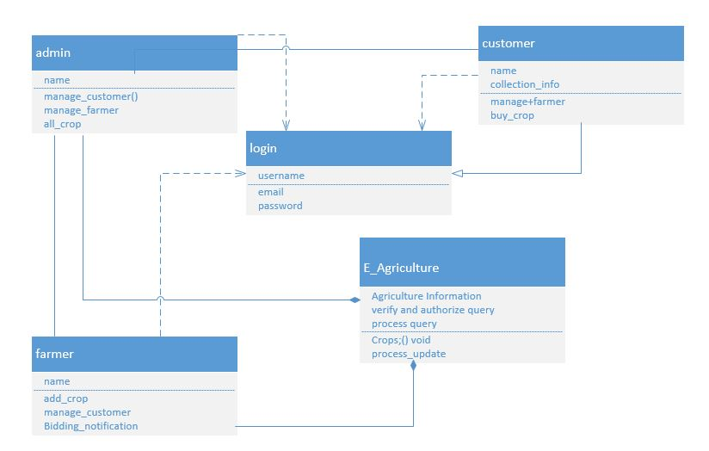

Use Case Diagram:

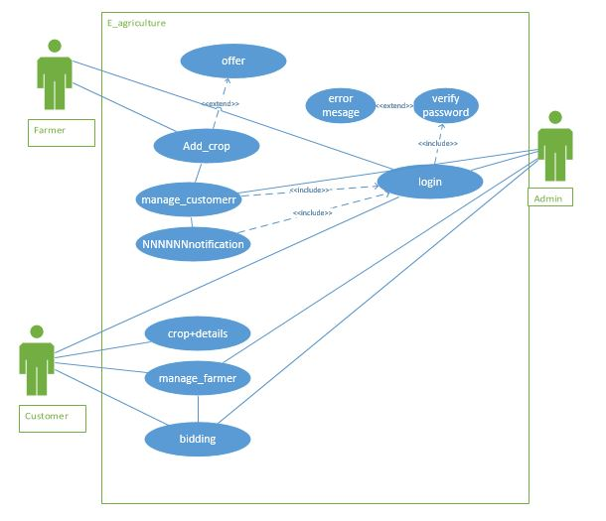

Data Flow Diagram (Level 1):

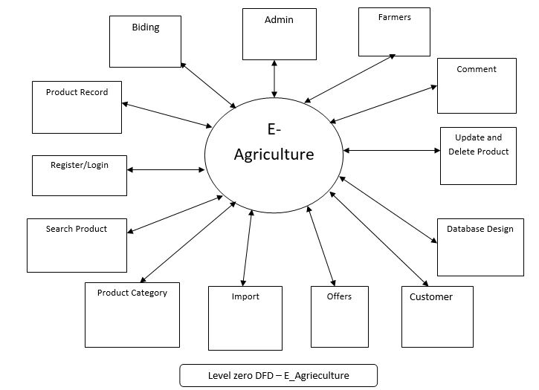

Data Flow Diagram (Level 2):

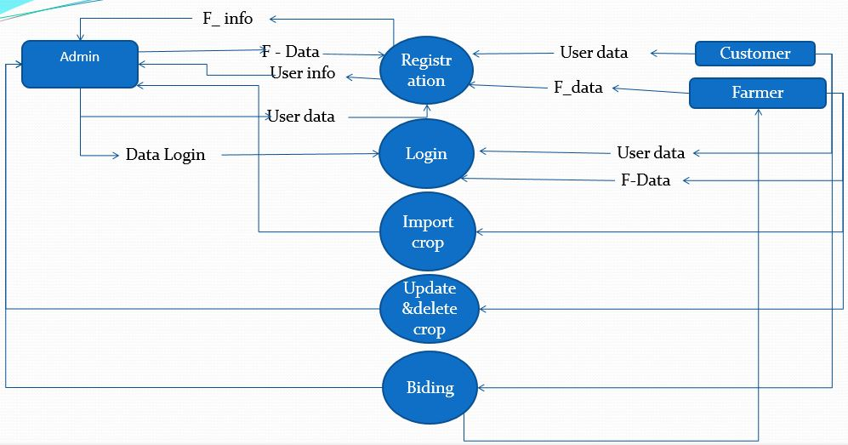

Sequence diagram:

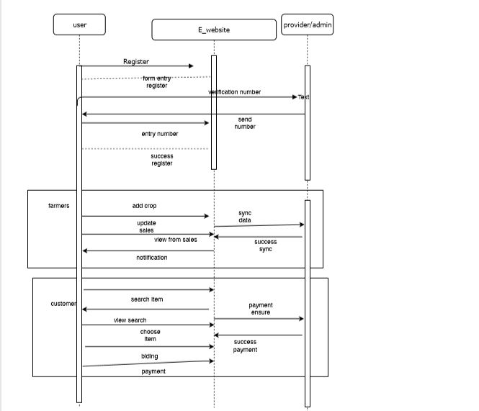

GANTT CHART:

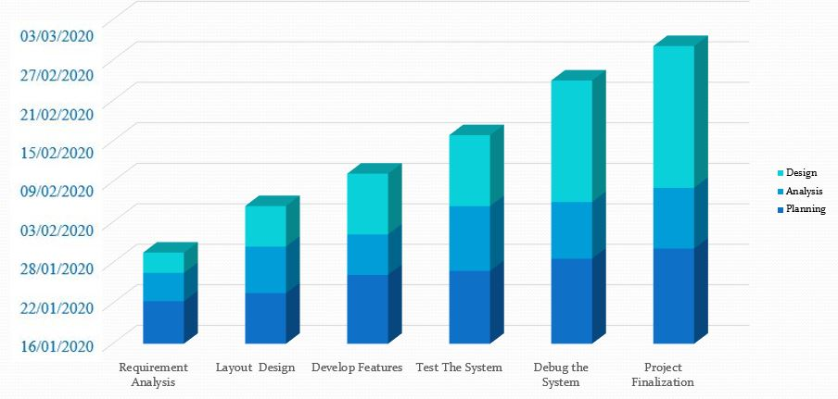

HARDWARE REQUIREMENTS:

For Pc or Laptop:

* + - * **Processor** 1,6 GHz CPU
      * **RAM** 3,5 GB RAM
      * **HDD** 1x 40 GB of free space or more is recommended for the software that is listed in the software requirements (system drive)

SOFTWARE REQUIREMENTS:

* Sublime text
* Xampp.
* HTML,CSS,JAVASCRIPT,MYSQL
* Laravel Framework

Future Plan:

* We will make also android app for this E- Agriculture project.
* We will add more feature in day by day.

ADVANTAGE:

* Save Effort and Time
* Easily farmer can sell crops
* Customer easily find & buy crops

DISADVANTAGE:

* + Increase Additional Cost
  + Must be Farmer are Experienced with using website
  + Must be planned When Crops time limited.
  + May Increase risk of bidding

CONCLUSION:

It can improve farming technologies by efficient farm management.

It helps in better marketing exposure and pricing and reduction of agriculture risks and enhanced incomes

REFERENCES:

[www.slideshare.com](http://www.slideshare.com)

[www.Wikipedia.org](http://www.Wikipedia.org)

[www.fao.org](http://www.fao.org)

[www.eagriculture.org](http://www.eagriculture.org)

[www.youtube.com](http://www.youtube.com)

[www.quora.com](http://www.quora.com)